Christopher Lunsford
CS-340
April 26, 2026
Project 2 Screenshots
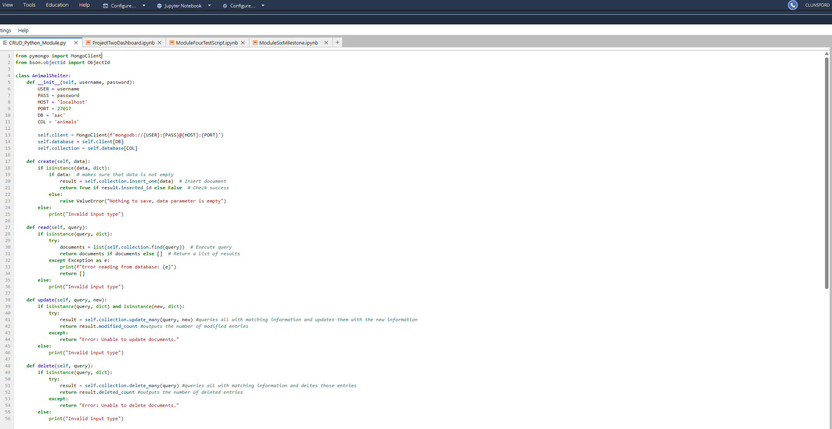
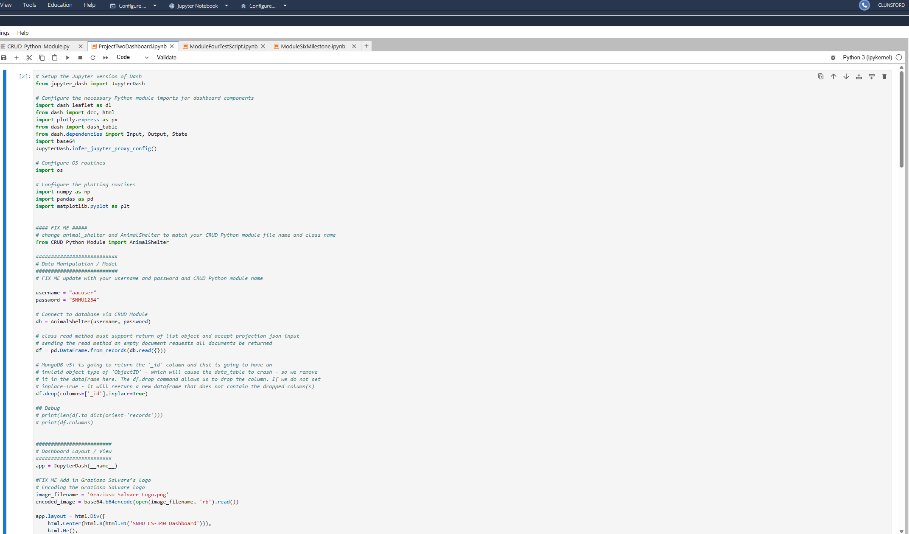
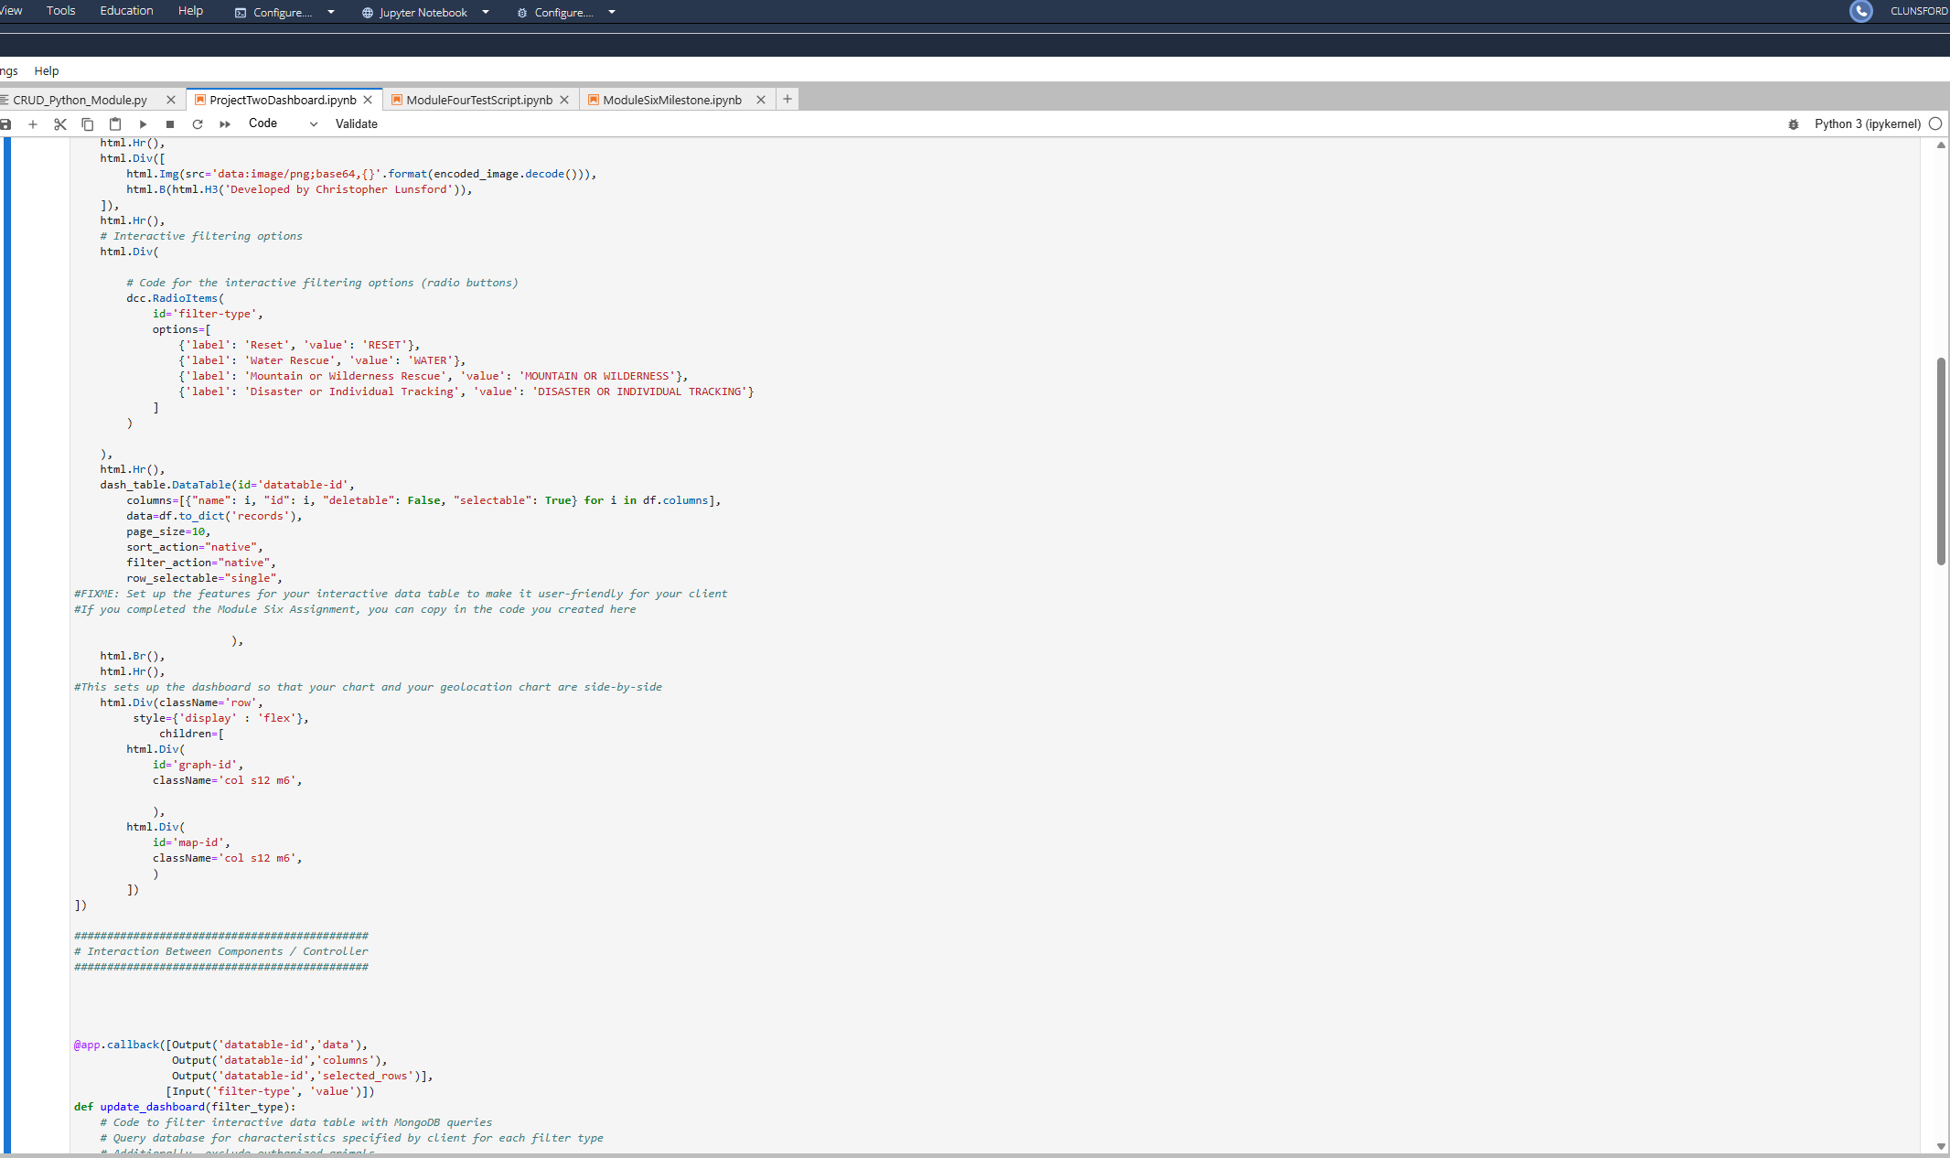
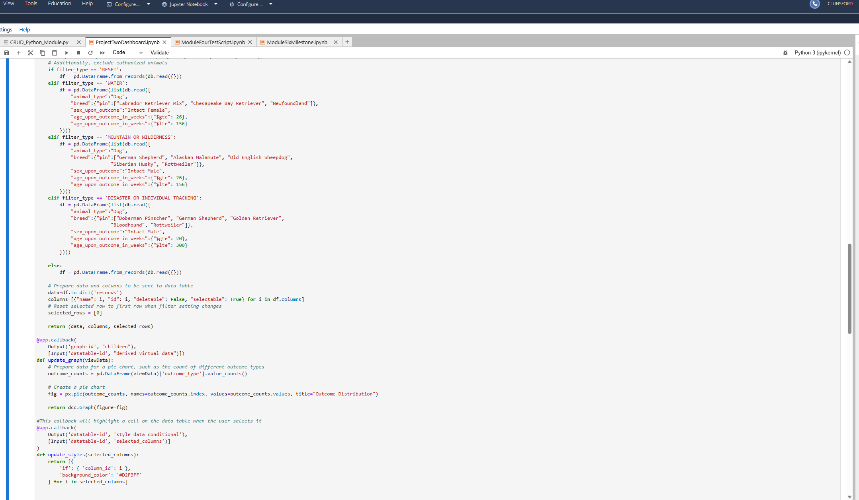
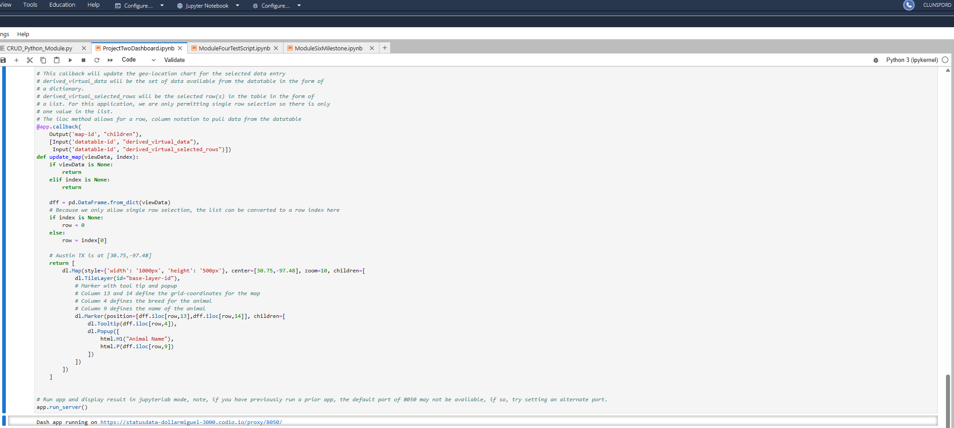
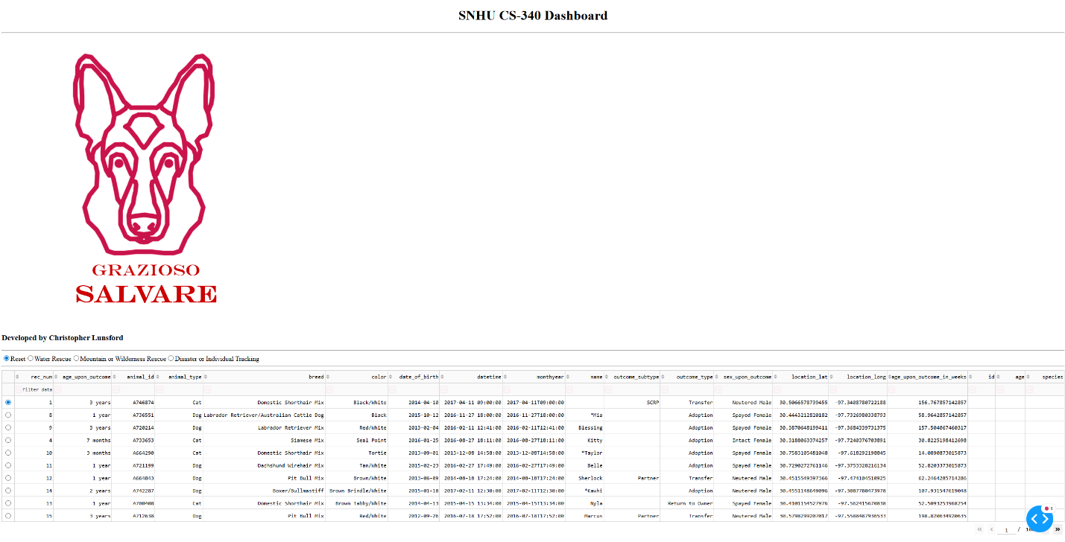
Screenshot showing unique html identifier and Grazioso Salvare Logo as well as unfiltered data table.
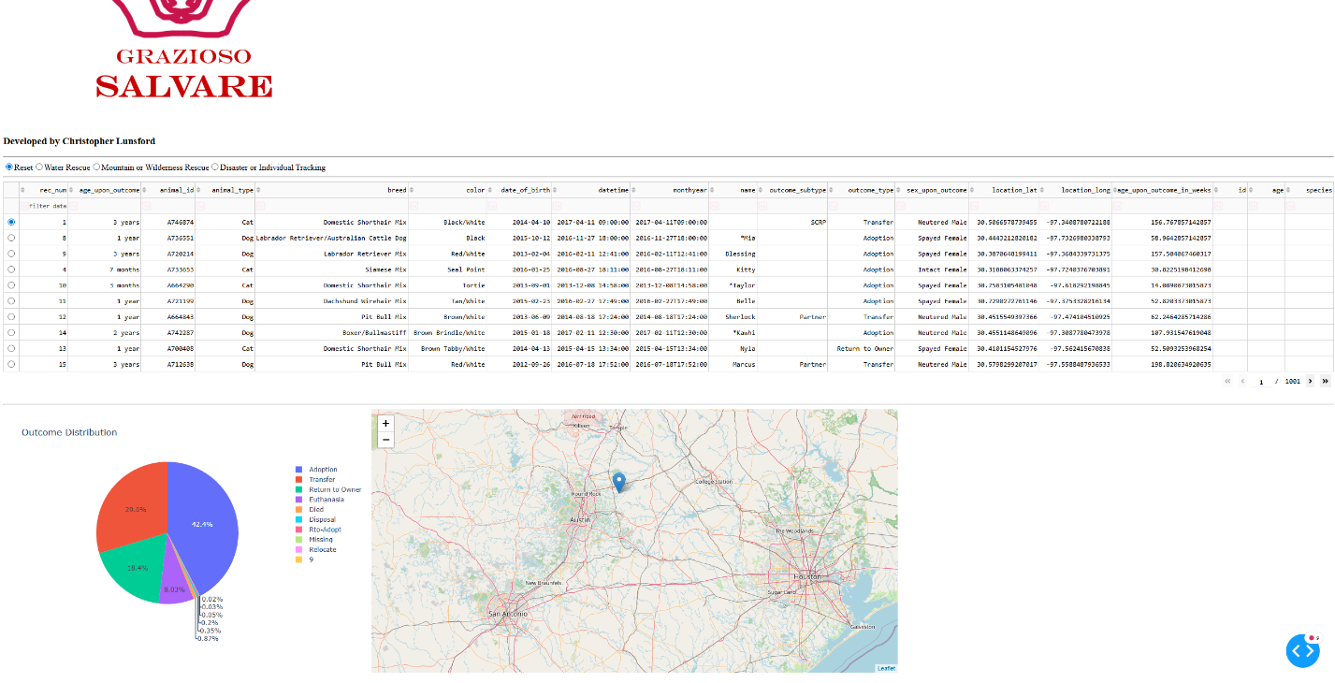
Screenshot showing geolocation capability and Pie chart based on outcome distribution
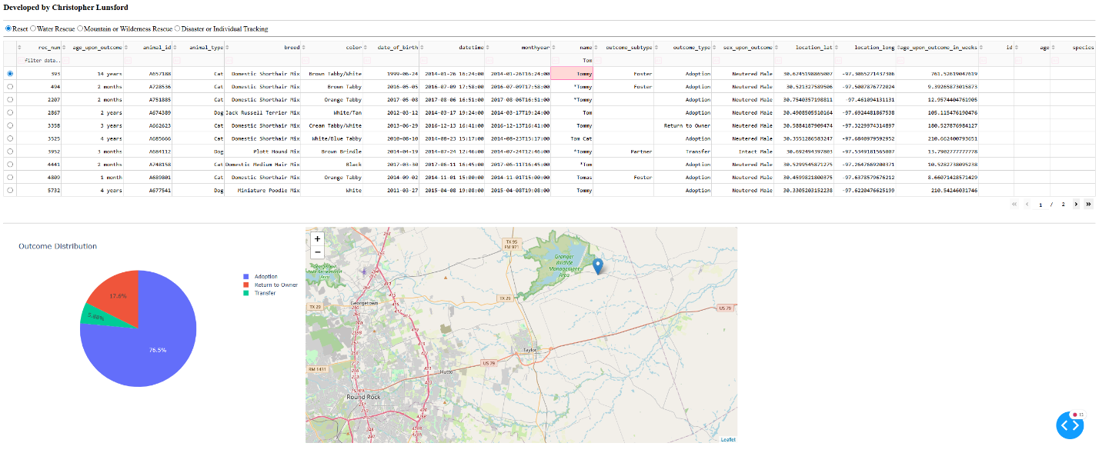
Screenshot showing filtering capability. Looking up Tom in the name column lists all animals with name Tom or including Tom in their name.
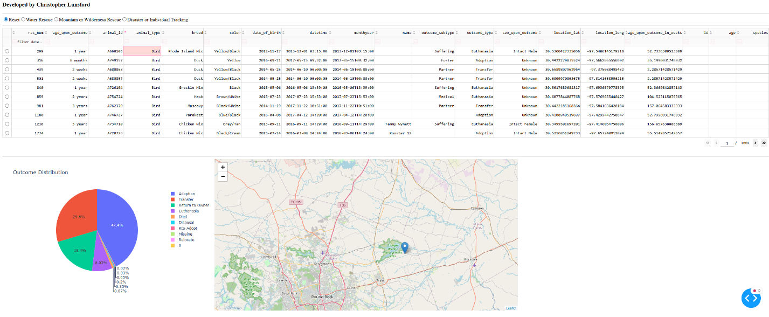
Another screenshot showing filtering capability by sorting animals by type, starting with bird.

